**Biology, Castle View High School Name: _____________________________  
Jason R Mayberry, PhD**

**Water and Electricity**

**Lab Preparation: Read the background information below, then complete items 1-5 below.**

|  |
| --- |
| **BACKGROUND**: Electricity is ubiquitous in our modern society; virtually every piece of modern technology is powered by electricity: lights, television sets, cars, air conditioners, phones, computers, radios, watches, and so on and so on. **Electricity is also ubiquitous to life**. All cells (animal, plant, fungi, bacteria, etc) conduct electrical currents as a matter of necessity to maintain their lives. Some cells such as muscles and neurons have a highly developed ability to conduct electrical currents necessary for their specialized functions.  **Generally speaking, there only two conditions that must be met to generate an electrical current.**   1. **Charged particles** 2. **The particles must be able to flow/move freely through some medium.**   When using a power source, such as a battery, to power some device, the charged particles are electrons. The electrons will only flow (condition 2 above) if there is a path (usually provided by wires) from the battery, to the item to be powered (e.g. a light bulb), and back to the battery; any break in this loop will prevent the flow of electricity.  *SO!, How are living cells able to conduct electrical currents?* As with many fundamental questions regarding life, the answer depends on the properties of water. This lab will explore the property of water that enables it to conduct electrical currents. To do this you will test a number of solid, pure liquids, and solutions for their ability to conduct an electrical current. |

**Lab Preparation: Do the following before starting the lab.**

1. Read through the methods section (begins next page) so you know what to expect during the lab.
2. Fill out the Predictions Table (found after the Methods section). Consider the properties of each item listed, then make a prediction about whether or not you think it will conduct an electrical current along with a reason for your prediction.

**Methods**

|  |  |
| --- | --- |
| 1. Clean any tarnish off of the copper probes by rubbing them with steel wool. Take care to never allow the steel wool to contact the batteries at any time during or after the experiment. 2. Lay out the following items as shown here.    1. Battery    2. Light bulb    3. Two Copper Probes |  |

1. 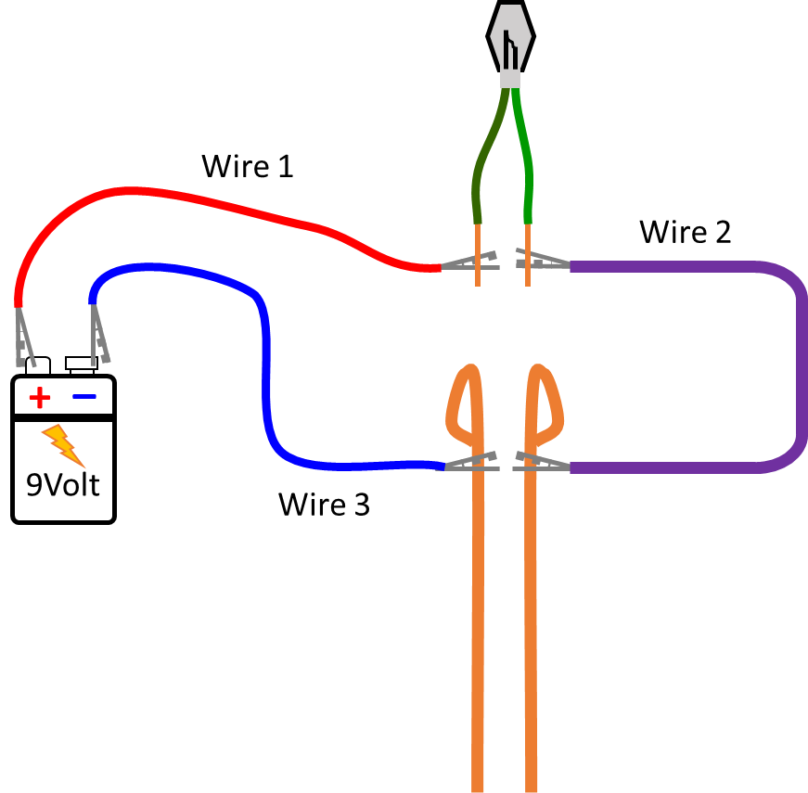Using three wires with Alligator Clamps, connect the pieces as shown. Note: *The color of the alligator clips is irrelevant.*
   1. With the **first wire**, attach the **alligator clamp** on one end to the Positive post on the battery, and the **alligator clamp** on other end to one of the wires from **the light.**
   2. With the **second wire**, attach the alligator clamp with one end to the other wire coming from **the light**, and the alligator clamp on the other end to one of the **copper probes,** near the looped end,
   3. With the **third wire**, attach the alligator clamp on one end to a different **copper probe**, near the looped end , and the alligator clamp on the other end to the negative post on the battery.

**Even though the wires are all connected, the light should still be off; why?**

1. 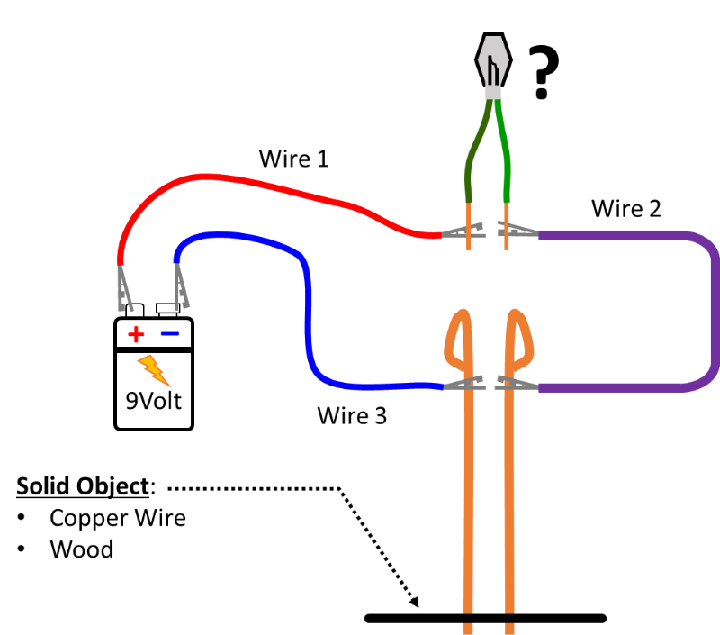**Control Items**:
   1. **Copper**: To test the ability of copper to conduct an electrical current, simply touch the two probes together. Metals have the unique property that even though they are solid, electrons are able to flow through them, allowing them to conduct electricity. If the light does not come on when the two probes are touched together, ask your teacher for assistance; because we know that copper can conduct electrical currents, we are using this as a positive control for the other experiments.
   2. **Wood**: Touch the copper probes to opposite ends of the wood stick. Record your observations
2. **Other Solids**: Get about a tablespoon full of each of the following in small individual cups, then touch the copper probes to different parts of the dry powder/crystals in the bottom of the cup. Record your observations.
   1. **Salt**
   2. **Sugar**
   3. **Baking Soda**
   4. **Corn Starch**
3. 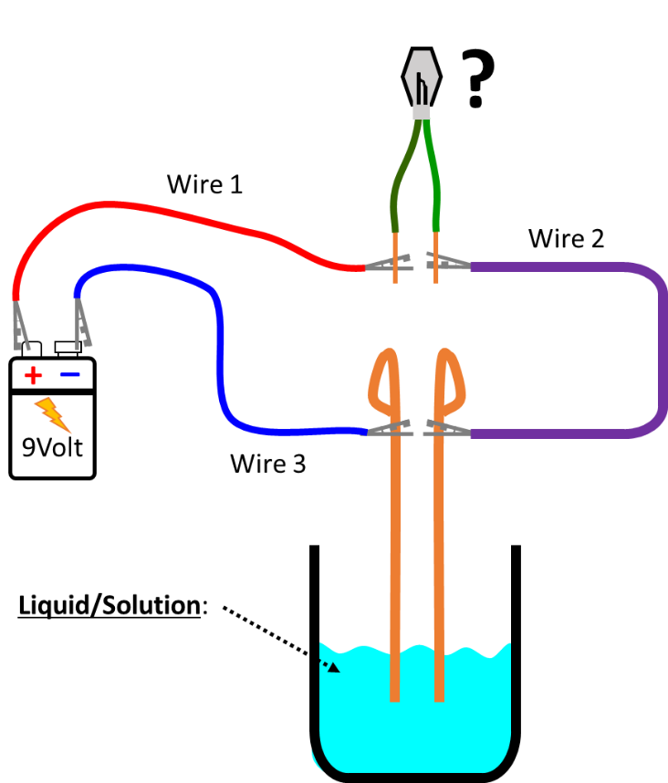**Liquids**: Fill individual cups about 1/3rd full with each of the following liquids. Use a paper towel to thoroughly wife off the ends of the copper probes before dipping in each of the solutions to test for a current. Without touching the probes one to the other, dip both probes in each solution at the same time. Begin with the probes at opposite ends of the cup, then gradually move them closer without letting them touch. Record your observations.
   1. **Distilled Water**
   2. **Vegetable Oil**
4. **Solutions**: To each of your cups with the solid crystals/powder, add water to a total volume of about 1/3rd of the cup, then stir to dissolve. Make sure to rinse and wipe off the stirring spoon between each solution. Then insert the probes as with the other liquids and record your observations. Make sure to thoroughly wipe the probes to clean them between each solution.
   1. **Salt Solution**
   2. **Sugar Solution**
   3. **Baking Soda Solution**
   4. **Corn Star Solution**
   5. **Vinegar**
   6. **Dish Soap (diluted 50/50 with water)**

**Predictions Table**

|  |  |  |  |  |  |
| --- | --- | --- | --- | --- | --- |
| **Solid Items (Controls)** | **Molecular Structure** | **PREDICTION**  **(Will Conduct Electricity? Yes or No)** | **REASON FOR PREDICTION** | **OBSERVATION (Light bulb on bright, on dim, off)** | **Other Observations? Other Indications of a Current?** |
| Copper Rod | Cu |  |  |  |  |
| Wood Stick | Poly CH12O6  (Cellulose) |  |  |  |  |

|  |  |  |  |  |  |
| --- | --- | --- | --- | --- | --- |
| **Other Solids** *(Powder or Crystals)* | **Molecular Structure** | **PREDICTION (Will Conduct Electricity? Yes or No)** | **REASON FOR PREDICTION** | **OBSERVATION (Light bulb on bright, on dim, off)** | **Other Observations? Other Indications of a Current?** |
| Solid Salt | **Na+Cl-** |  |  |  |  |
| Solid Sugar | See the source image |  |  |  |  |
| Solid Baking Soda | Image result for sodium bicarbonate |  |  |  |  |
| Solid Corn Starch | See the source image |  |  |  |  |

|  |  |  |  |  |  |
| --- | --- | --- | --- | --- | --- |
| **Other Liquids** | **Molecular Structure** | **PREDICTION (Will Conduct Electricity? Yes or No)** | **REASON FOR PREDICTION** | **OBSERVATION (Light bulb on bright, on dim, off)** | **Other Observations? Other Indications of a Current?** |
| Pure Water (Distilled) |  |  |  |  |  |
| Vegetable Oil |  |  |  |  |  |

|  |  |  |  |  |  |
| --- | --- | --- | --- | --- | --- |
| **Solutions** | **SOLUTE STRUCTURE** | **PREDICTION (Will Conduct Electricity? Yes or No)** | **REASON FOR PREDICTION** | **OBSERVATION (Light bulb on bright, on dim, off)** | **Other Observations? Other Indications of a Current?** |
| Salt (NaCl) Solution | **Na+Cl-** |  |  |  |  |
| Sugar (Sucrose) Solution | See the source image |  |  |  |  |
| Baking Soda  Solution | Image result for sodium bicarbonate |  |  |  |  |
| Corn Starch  Solution | See the source image |  |  |  |  |
| Vinegar (Ascentic Acid) Solution | See the source image |  |  |  |  |
| Dish Soap (mix 50/50 with water) | https://qph.fs.quoracdn.net/main-qimg-677b0f98773991412c1206c022e72732 | **­­­­** |  |  |  |

**Conclusions and Discussion**

1. What property do the solutions that conducted an electrical current have in common?
2. Did pure water conduct an electrical current? Explain why or why not?
3. Did vegetable oil conduct an electrical current? Explain why or why not?
4. Were any of your initial predictions incorrect? If so, explain why the reason for your prediction is wrong.